INFO 6205 Spring 2022 Project

Menace

**Submitted By:**

Manoj Reddy Amireddy (002196218)

Anshita Verma (001007320)

Varun Vupalla

Introduction

**Aim:**

•Implement “The Menace” by replacing matchboxes with values in a hash table (key will be the state of the game).

•Train the Menace by running games played against “human” strategy, which is based upon optimal strategy (see Tic-tac-toe).

**Approach:**

1. We are training the system itself to get better as it plays the game. In this way it can improve itself in making the next move.
2. Initially we are generating all the possible stages of the game and storing them.
3. These stages may have duplicates, since rotating the board and flipping the board results in the same state.

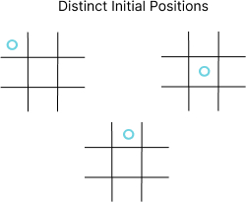

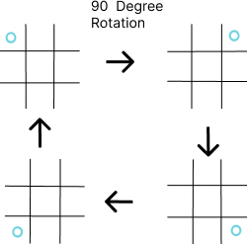

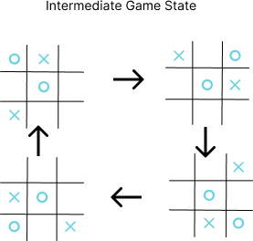

.

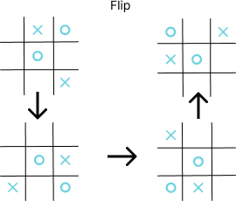

1. So, we remove the duplicates by checking with the other states. Finally, we will be left with all the unique states that are possible to occur while playing the game.
2. Once we have the states, we finally use them to represent as a Matchbox in our system.
3. Now for each state we get the possible next moves that it can make and place that (Beads) in the Matchbox with an initial equal no of them for giving equal probabilities for each move.
4. To train the system, we will make the system to play against a Random gamer.
5. This we take as an input form the user to run the desired no of games to play for training.
6. The training games happen alternatively, so that Random gamer and System makes the 1st move.
7. The Random user makes a move by just randomly choosing the empty place.
8. The system makes the move by randomly picking one of the beads in the Matchbox. These beads have different probabilities for each possible move.
9. We keep track of these moves made by System and the state of the game that it referred to make that move.
10. If the game was Over and the System has WON, then we reward the system with adding extra beads to the move in the Matchbox that it made in the game. It improves the probability of the outcome of this move if it ever sees the same stage in later games.
11. If the game is LOST by System, then we remove the beads of that move it made through the game for each state. So that we are trying to reduce the probabilities of the move in later games it plays and sees the same state again.
12. If the game is DRAW. We just do nothing.
13. This way we train the system and finally flush the trained states and their beads to a CSV for later use in playing against the Real Human.
14. The CSV has the contents in the format of the state comma separated with the bead's values for those positions.
15. In order to play against the Real human, we use this CSV file and build the whole Trained menace game states by parsing the values line by line with the state and its beads.
16. After each game with the Real Human, we get the Game status and then update the Beads in the Matchbox to train the System again.
17. We print the probabilities at every stage of making a move by System in the console.

Program

**Data Structures and Classes:**

**DataStructures**

1. **Arrays** used to keep track of the state of the game.
2. **HashMap** is used to map the State of the game (Matchbox) to its corresponding Beads statuses.
3. **List** is used to keep the Beads counts in the Matchbox with its position and its counts.

**Logic Classes**

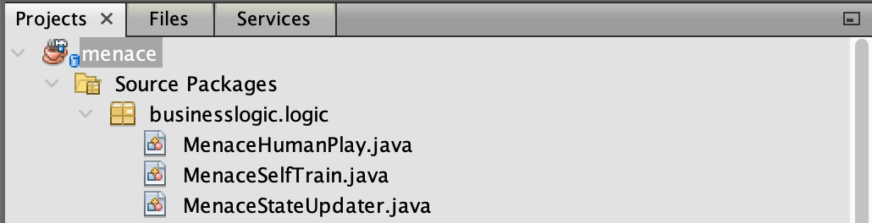

**Model Classes**

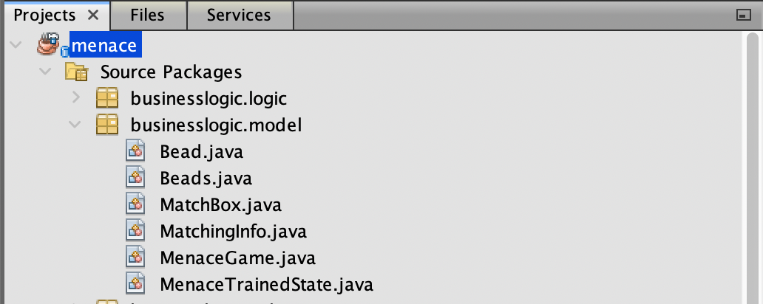

**Util Classes**

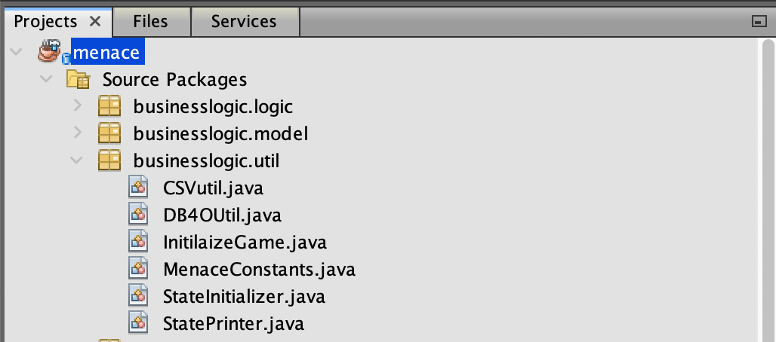

**UI Classes**



**Algorithm:**

1. We have built a HashMap that maps each state of the Menace Game with the Matchbox. This Matchbox has the beads count for each viable move that it can make.
2. Every move the system makes refers to this Matchbox and gets a random shuffle of the beads. We keep track of this Matchbox and the move it made.
3. Once the game is over. Based on the status whether it's won by a System or not we reward the System by adding extra bead to the Matchbox or remove a bead by using the GAMMA, BETA, DELTA values.
4. After every game the Beads count in the Matchbox changes, and it makes the next move differently than completely random as the counts are different for each viable position.

**Invariants:**

1. At any stage of the game if you flip the game and rotate it clockwise by 90,180,270 degrees. It always results in the same game.
2. Even rotating without flip by 90,180,270 degrees also results in the same game.
3. Also, if a game is either started by the user or the menace, they always refer to the same Matchbox for making the next move. This could remove the initial condition of System to start first always.
4. Whoever starts the game the state of the game will be same as the state is independent of the player.

**UI Design:**

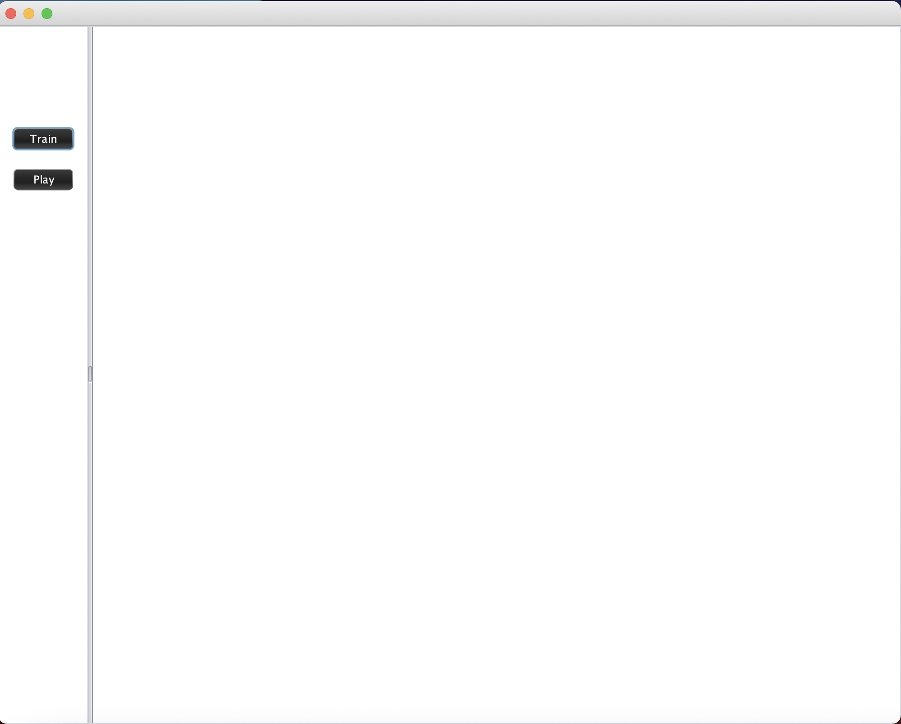

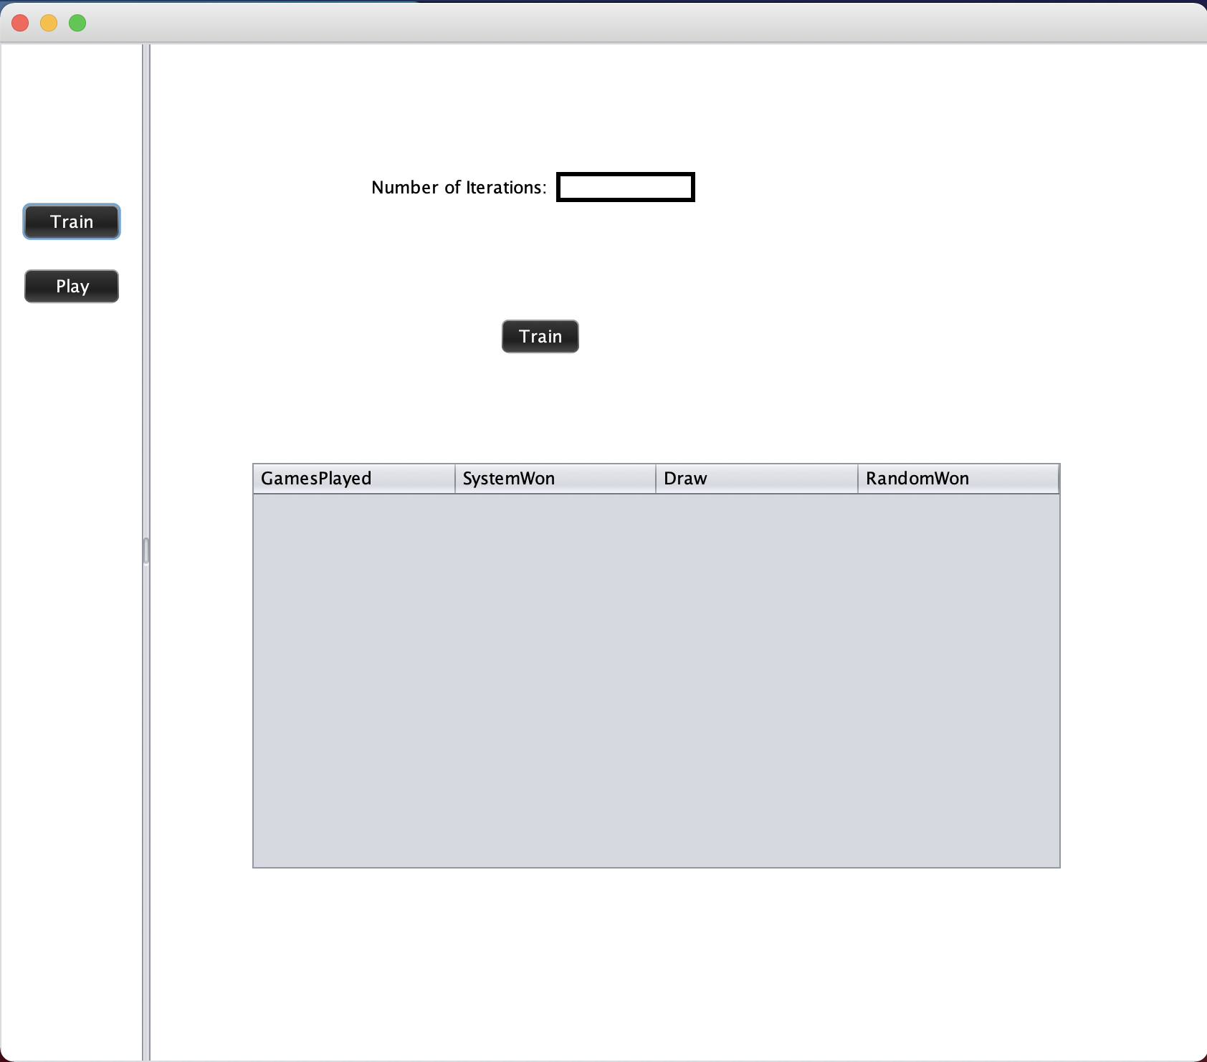

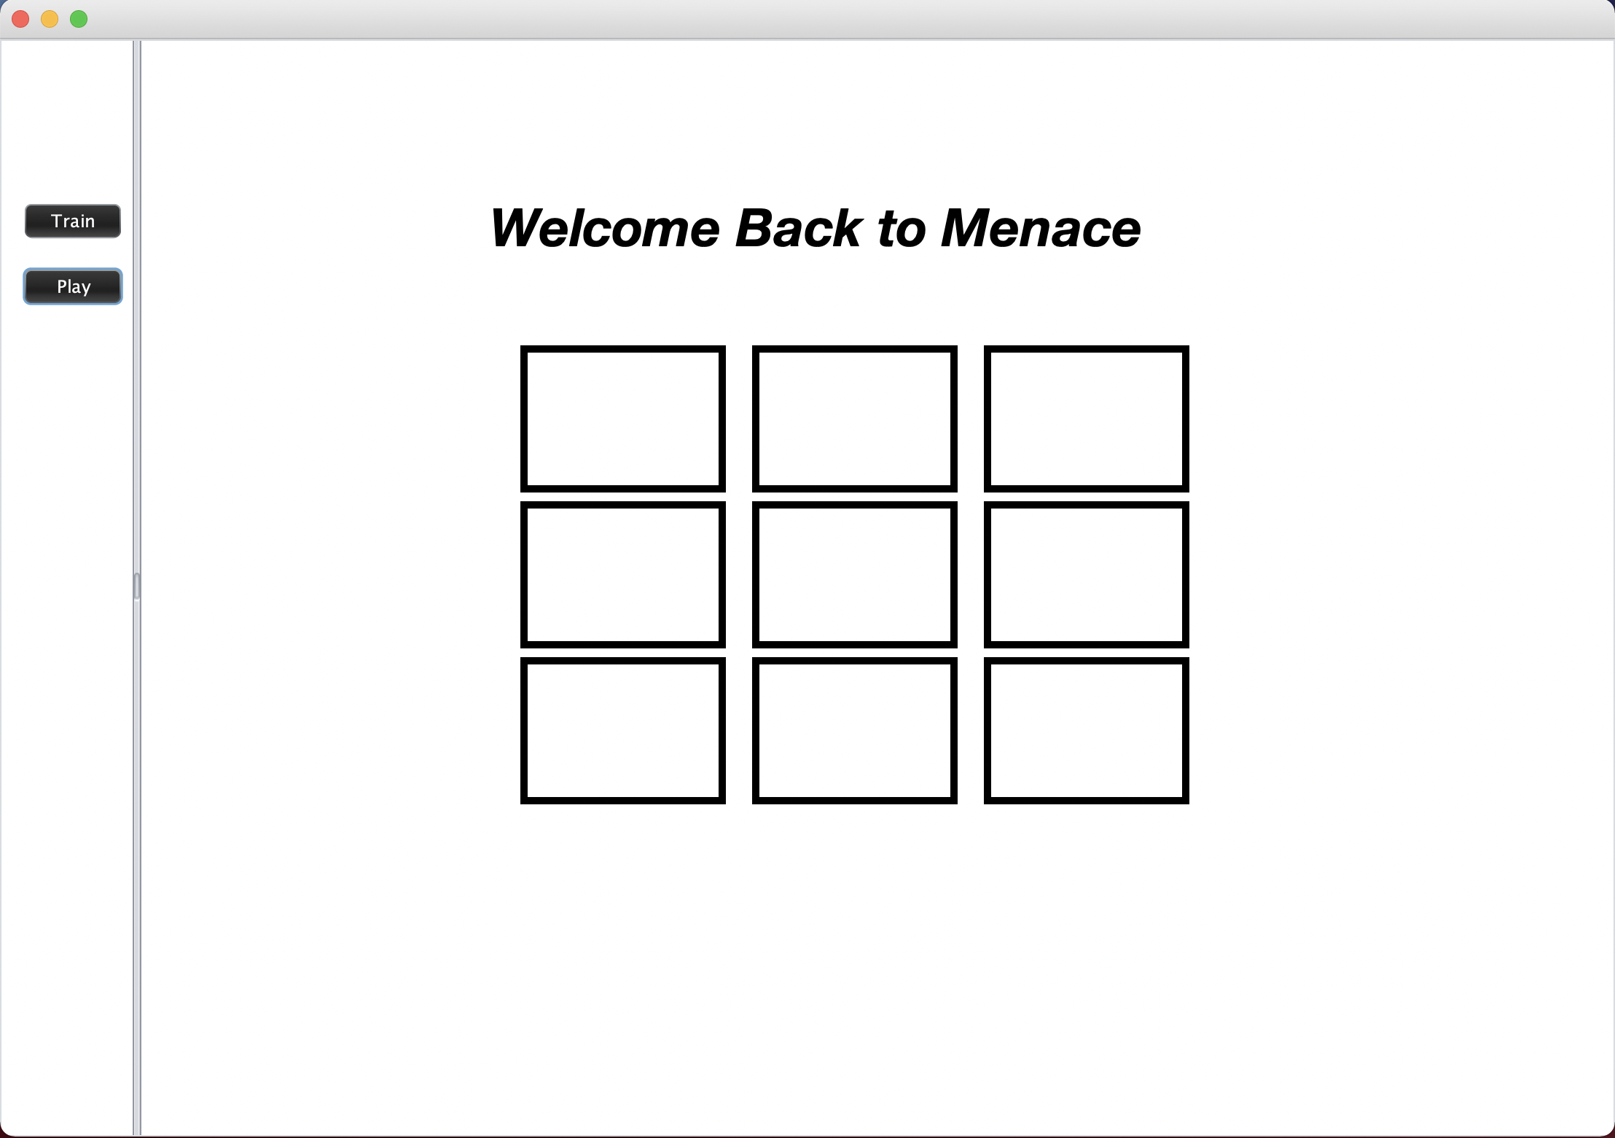

Application allows to train the machine:

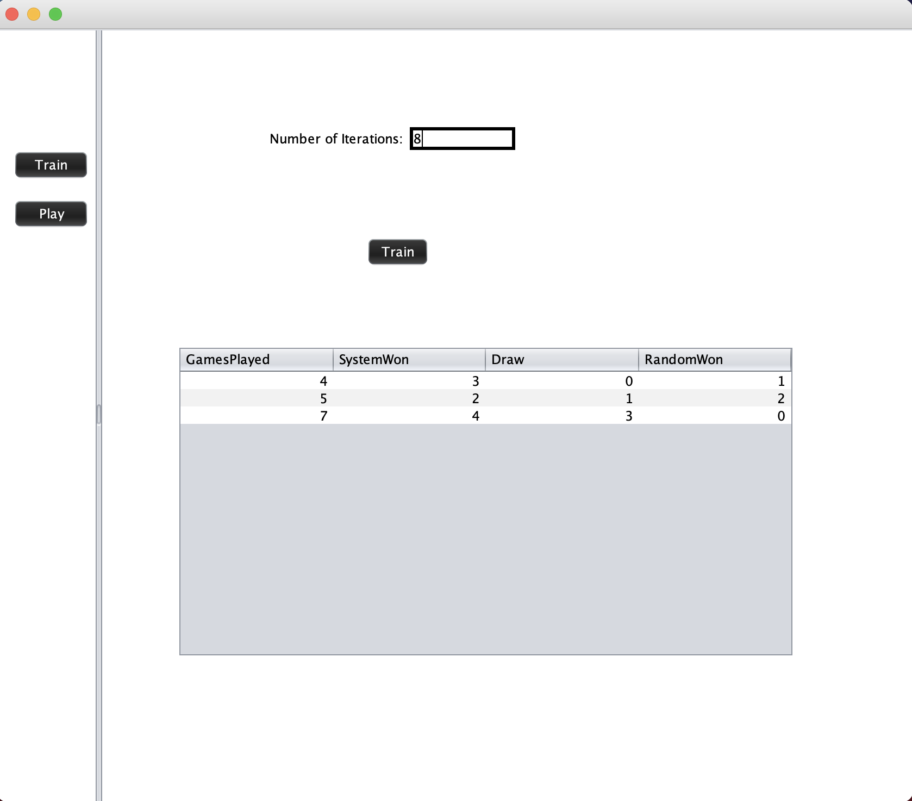

Application asks user to choose to play first move:

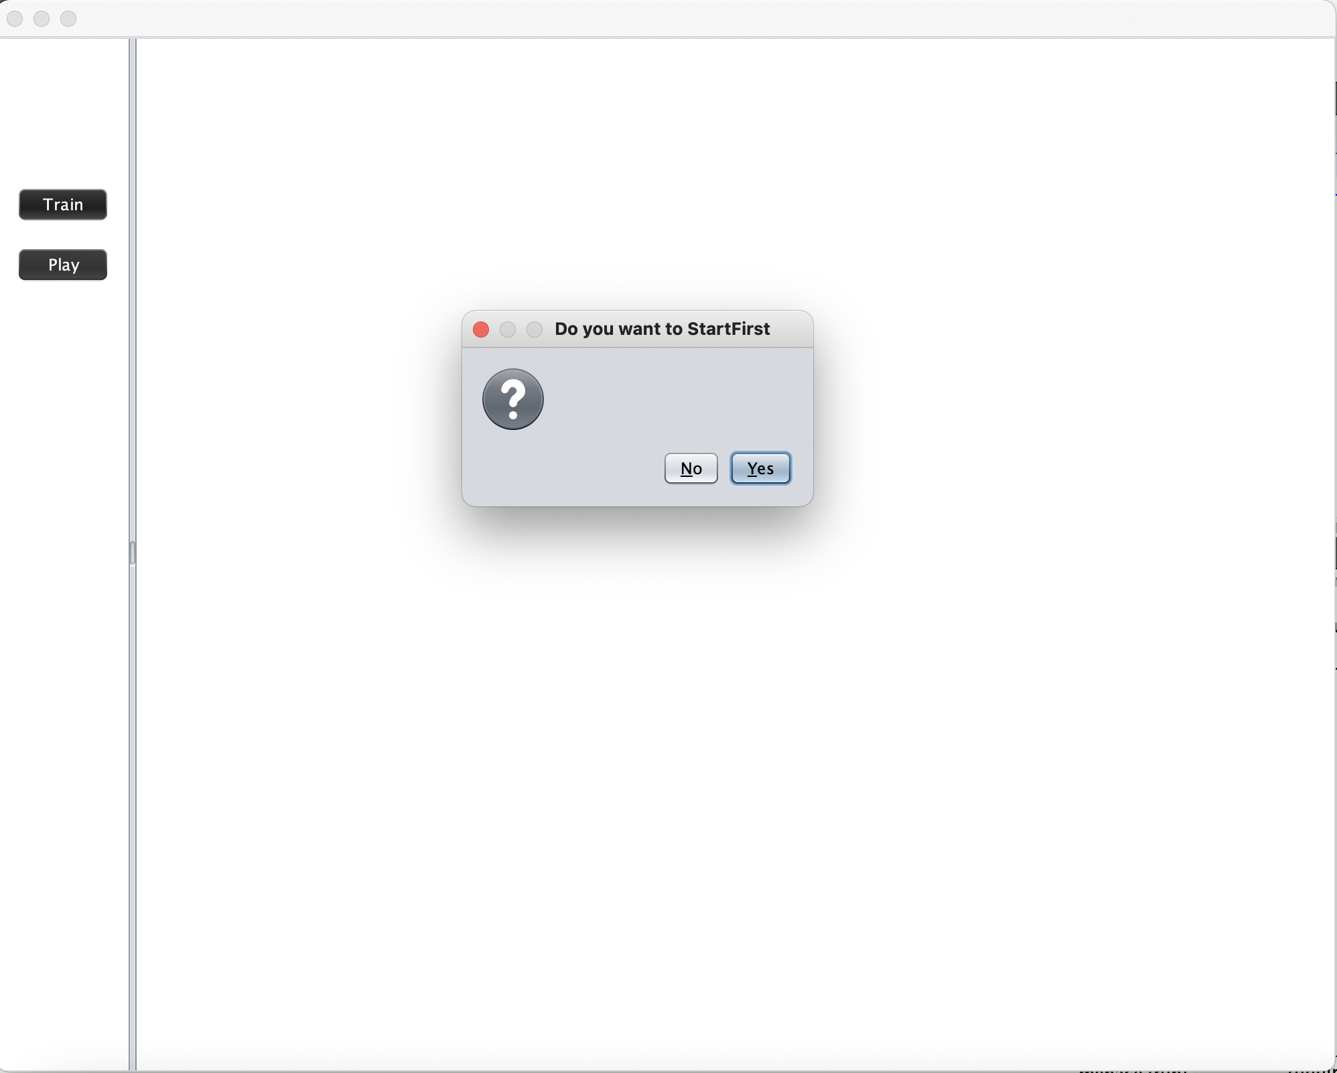

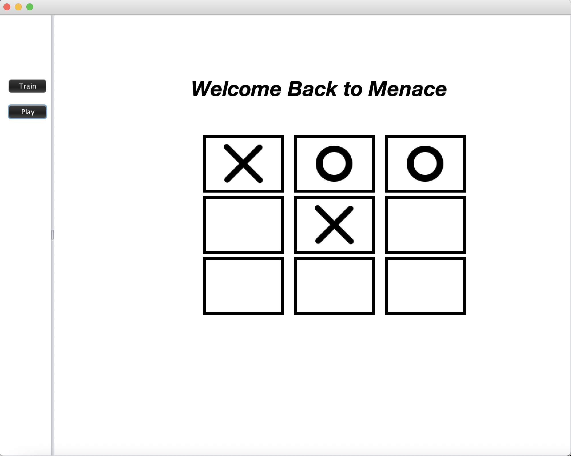

If the user wins:

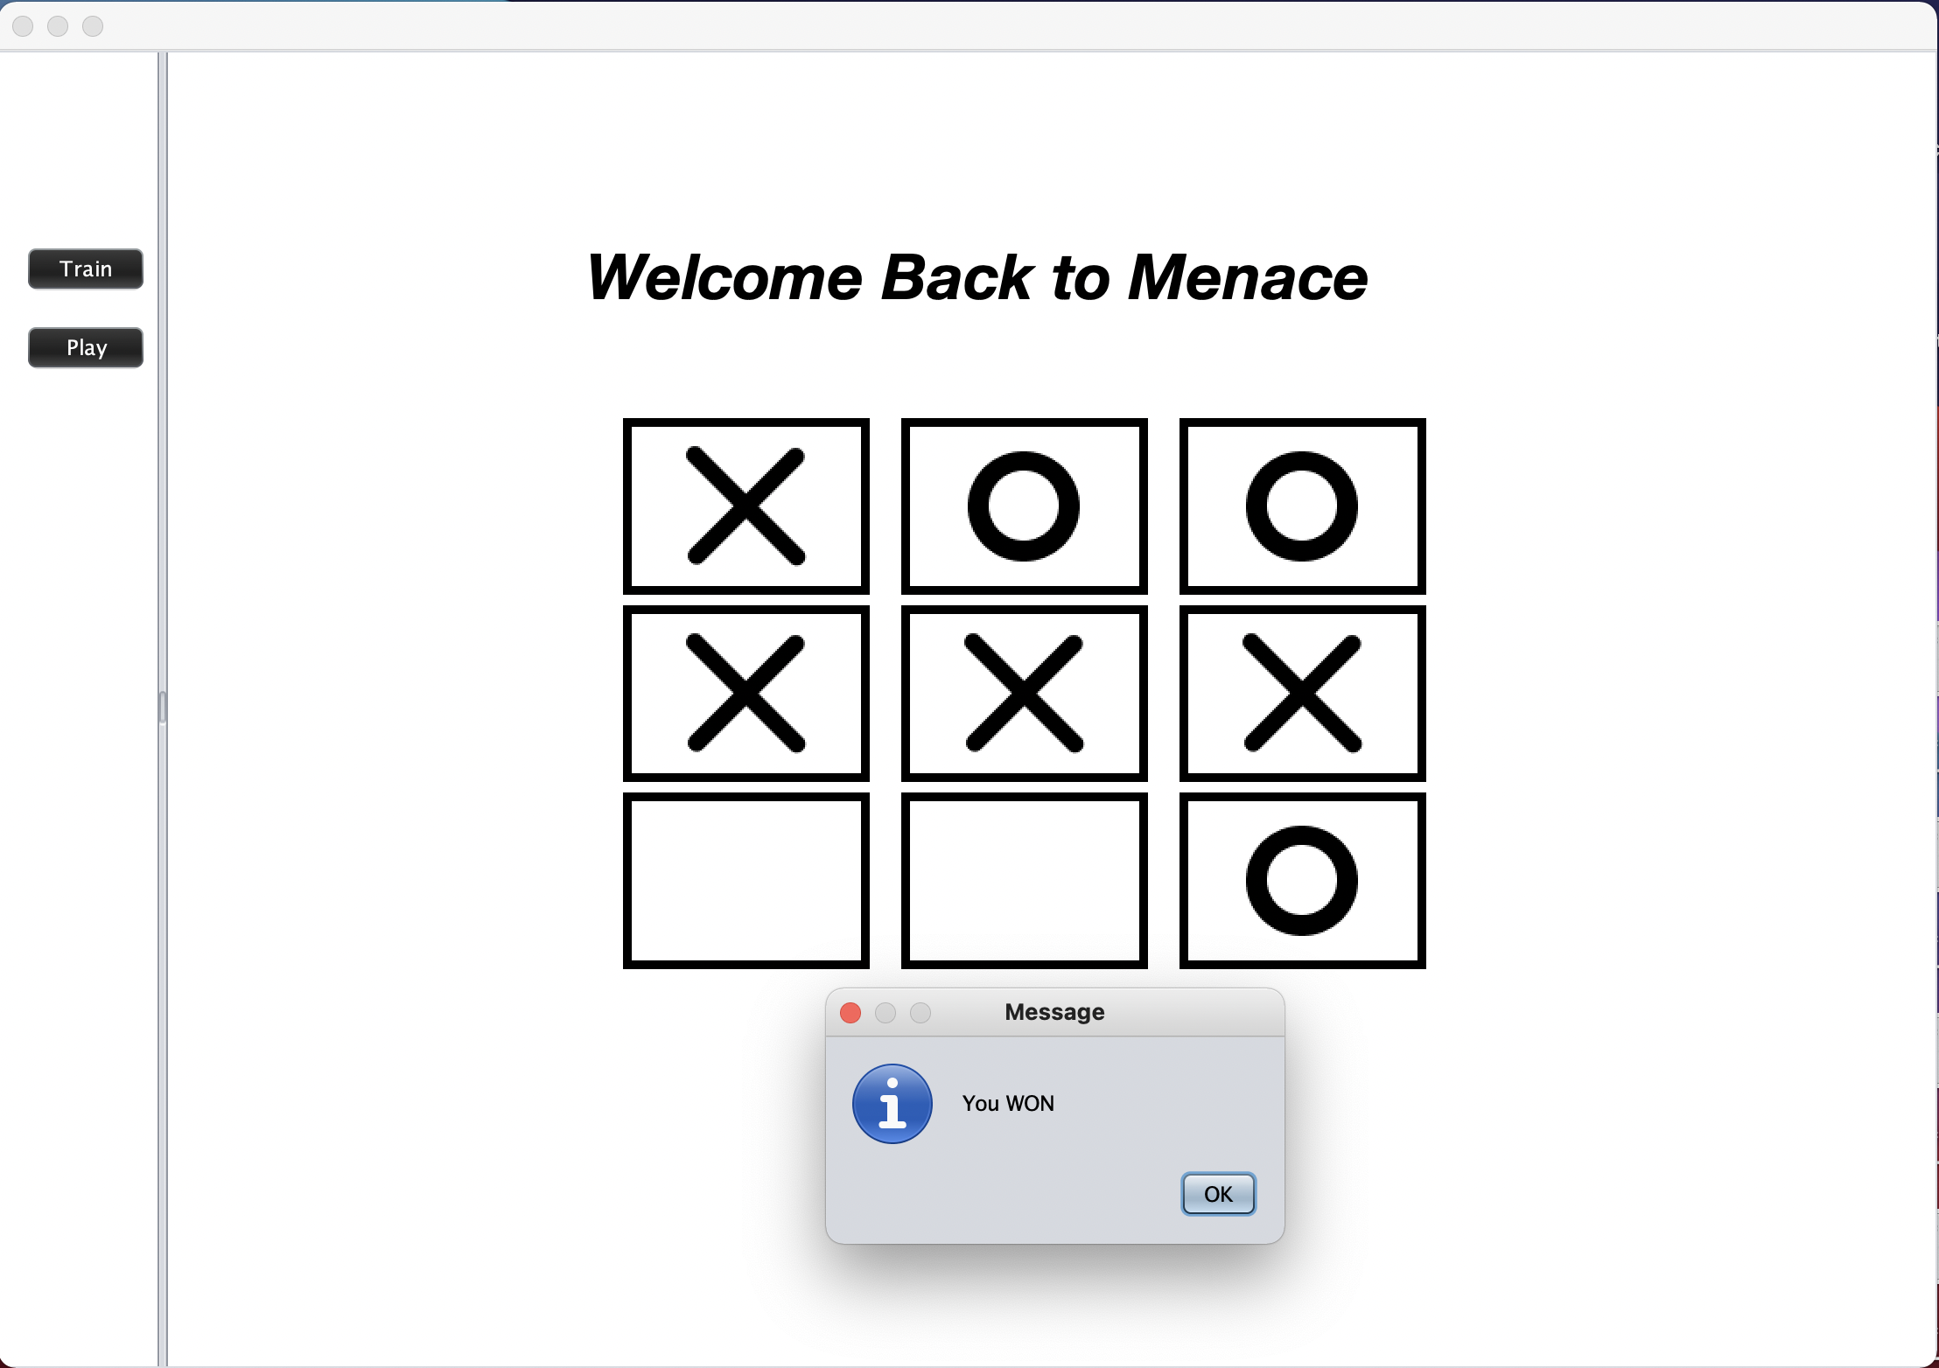

If the machine wins:

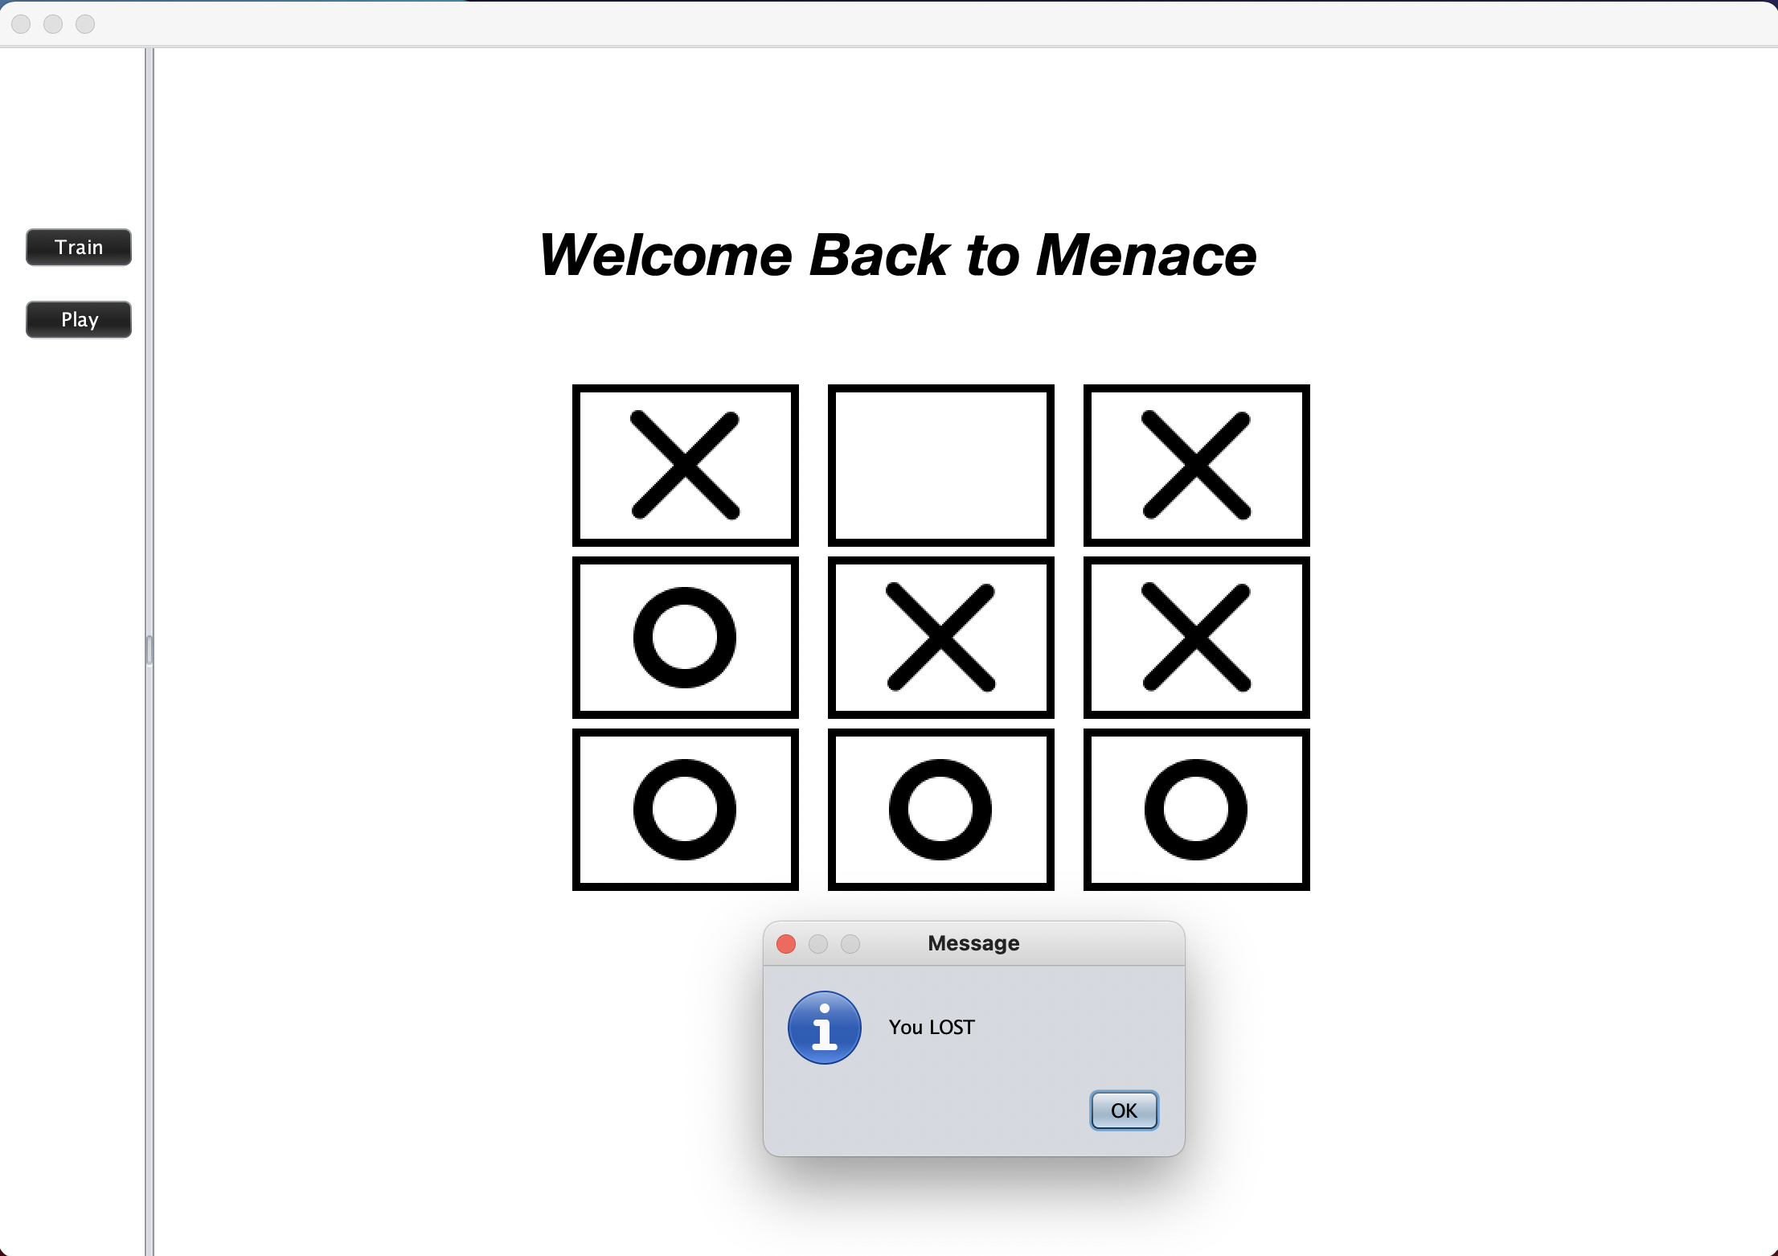

If game results in Draw:

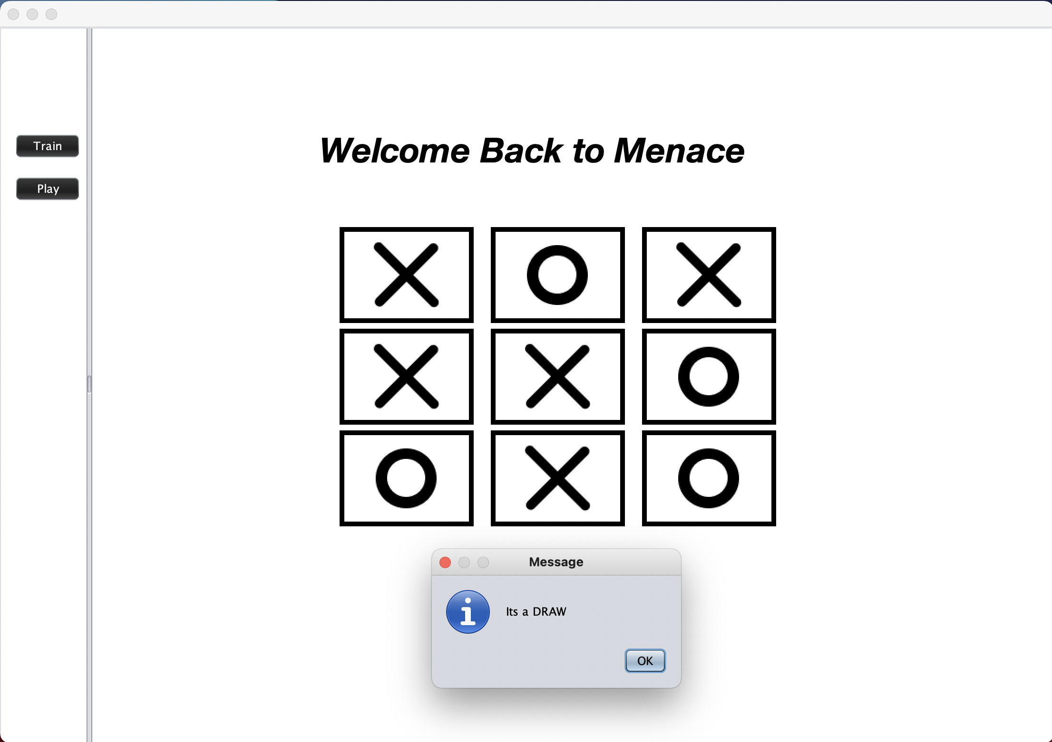

Flow Charts

UML Diagram

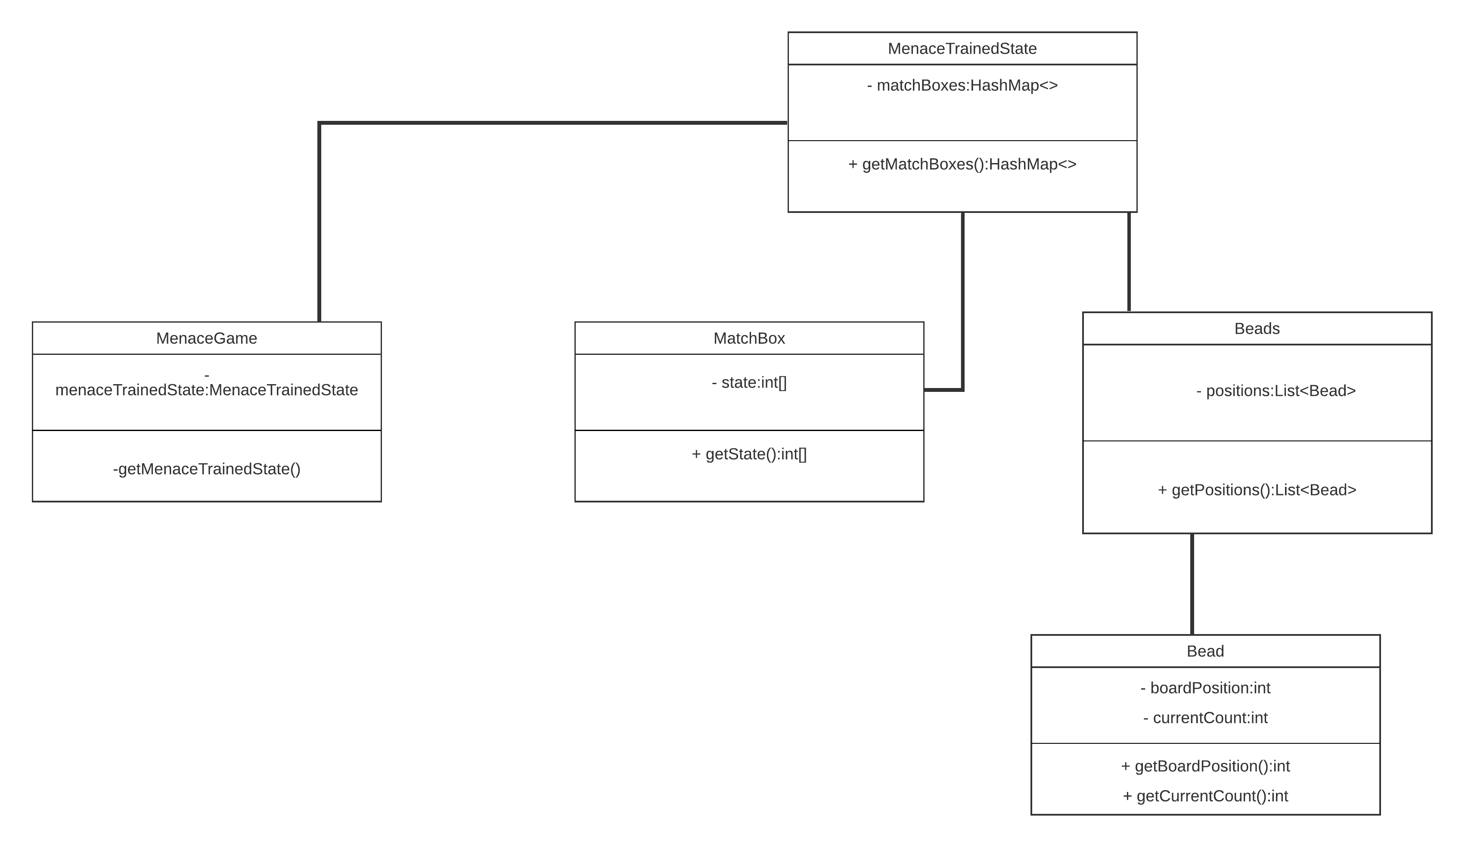

UI Flow

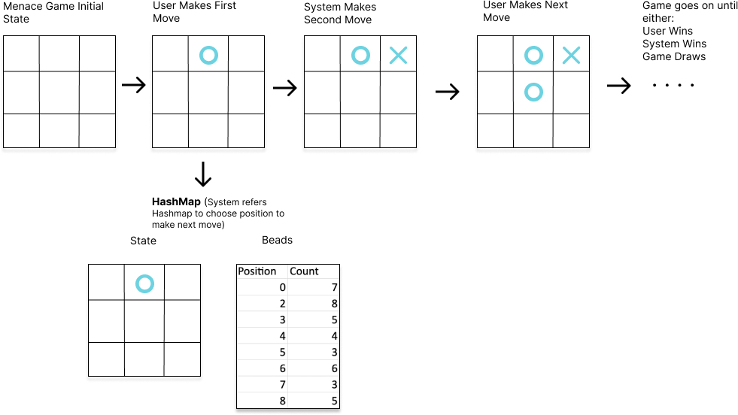

Observation And Graphical Analysis

Performed menace game with different values of ALPHA, BETA, GAMMA,

DELTA. Trained the machine by playing up to 50, 100 and 150 games.

Below is the graphical analysis for each experiment on Menace Game:

ALPHA: 10 BETA:1 GAMMA:1 DELTA:0

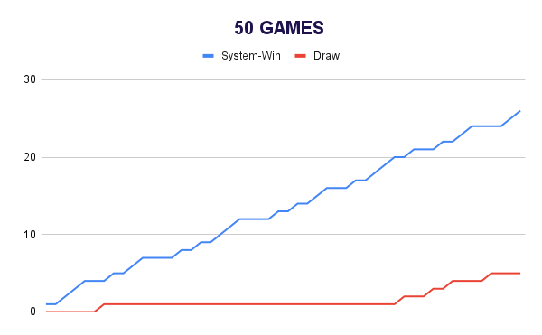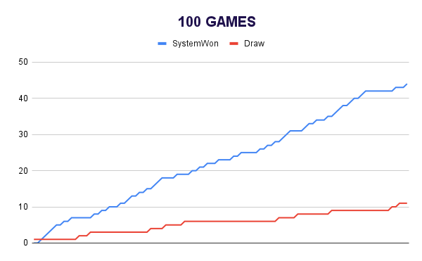

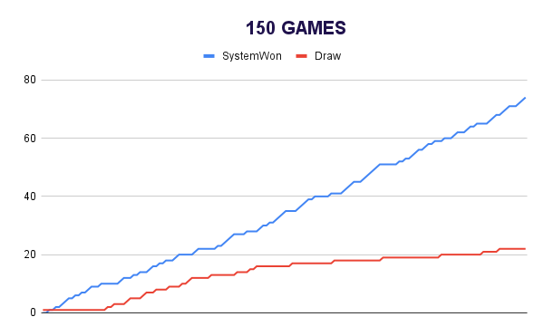

ALPHA: 10 BETA:1 GAMMA:1 DELTA:1

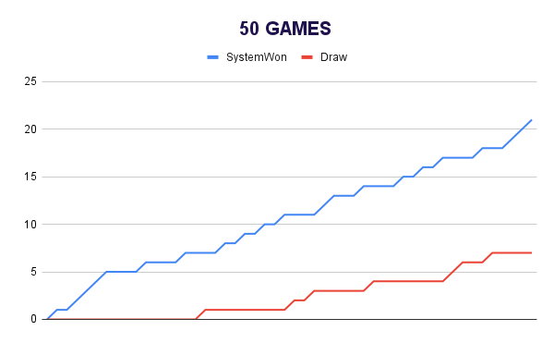

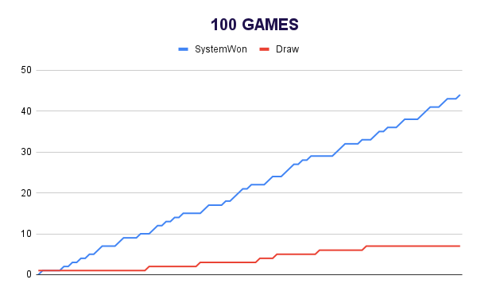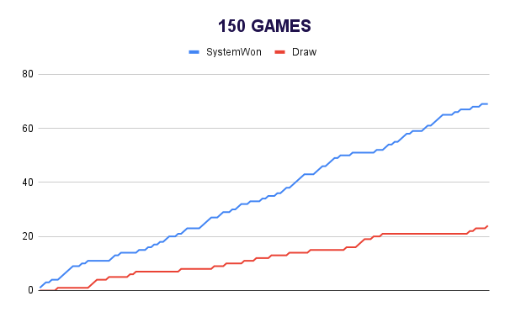

ALPHA: 10 BETA:1 GAMMA:2 DELTA:0

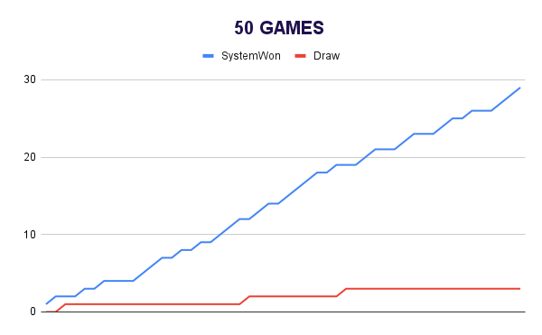

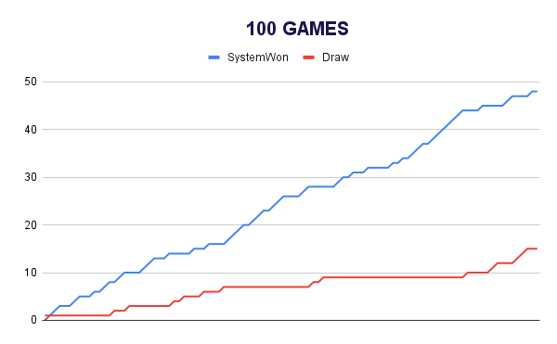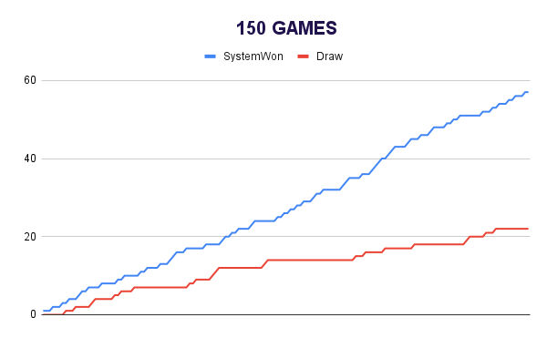

ALPHA: 10 BETA:2 GAMMA:1 DELTA:0

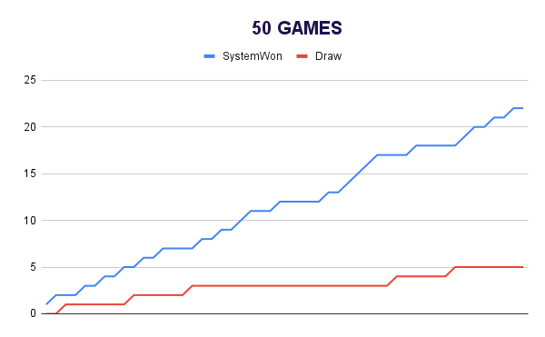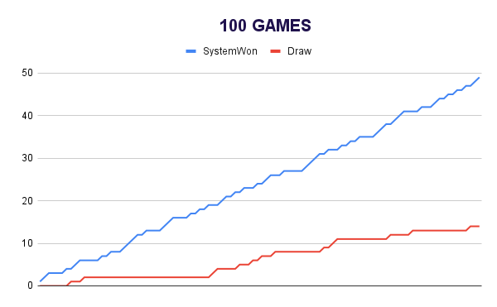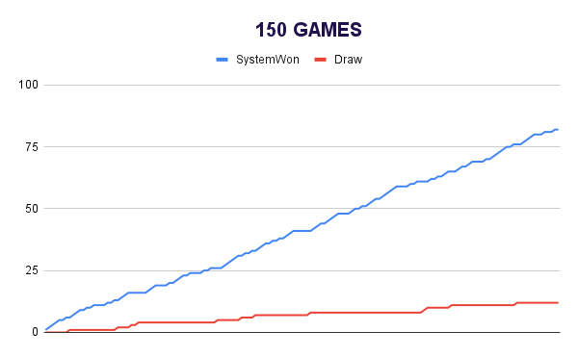

ALPHA: 30 BETA:1 GAMMA:1 DELTA:0

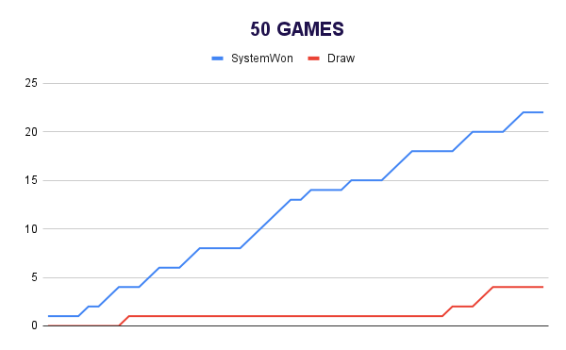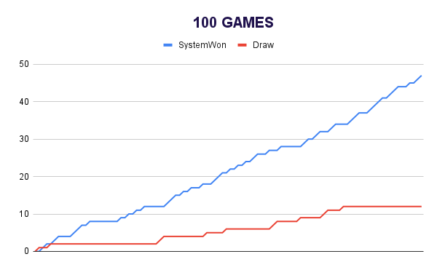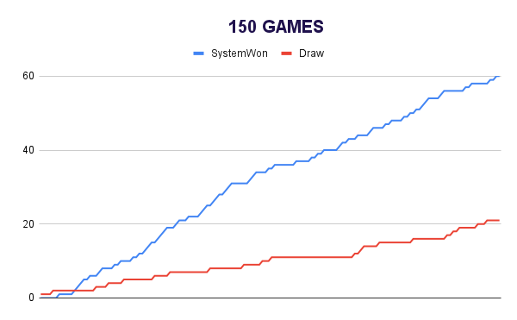

ALPHA: 30 BETA:1 GAMMA:2 DELTA:0

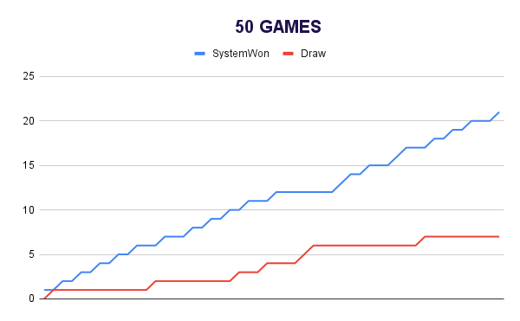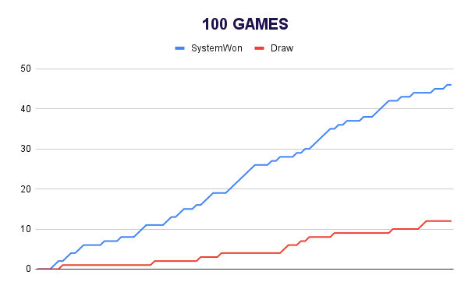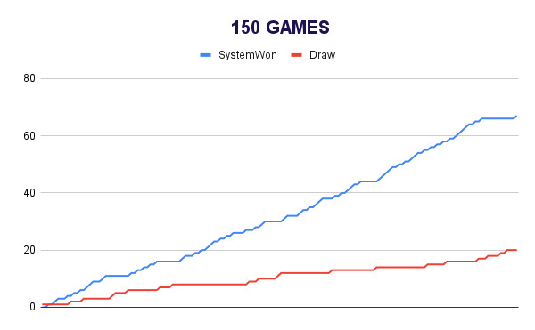

ALPHA: 30 BETA:2 GAMMA:1 DELTA:1

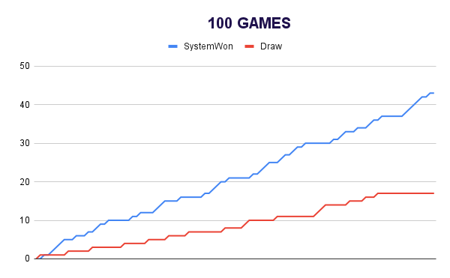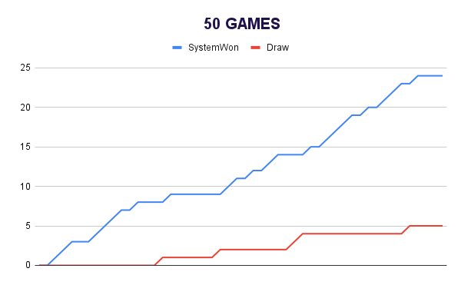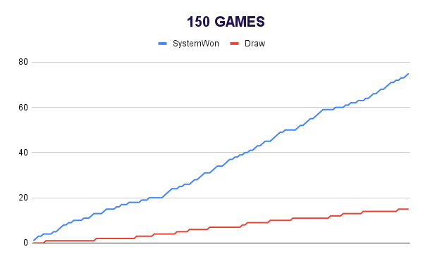

It could be observed from the graphical representation that the number of games won by system and number of draws increases with the number of games played.

Results And Mathematical Analysis

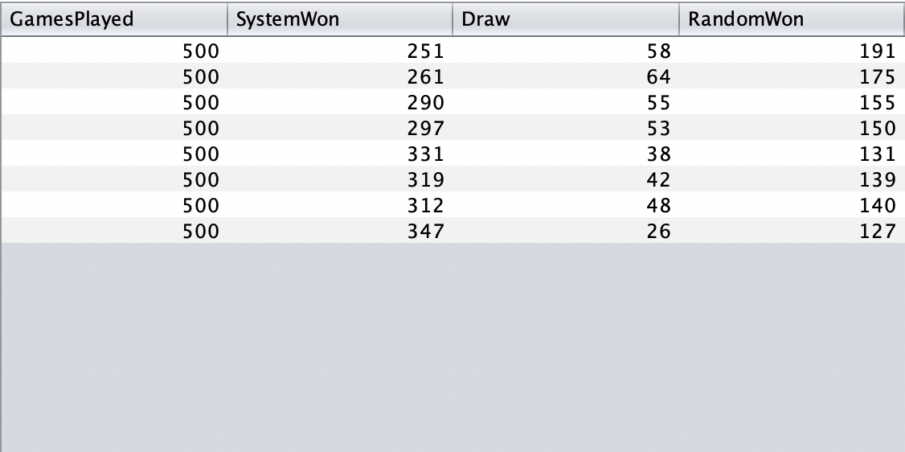

As we see in the above images, we can clearly see that Menace is trying to learn against all the possible states and moves it can make and win the games with the more no of Games.

To explain it mathematically, as we play more games the probability (p) for the move is increased if the menace has won a game and its more likely to pick it again in future as we increment the beads count for that position in the Matchbox.

Alpha-10, Beta-1, Gamma-1, Delta-0

Intermediate state in the Move of a winning game of a menace

State - 0,1,2,1,0,0,1,2,2

Beads state -- 10,0,0,0,11,9,0,0,0 (Probabilities --- 0.33,0,0,0,0.36,0.3,0,0,0)

After adding Beads for winning move at position 5

Beads state -- 10,0,0,0,11,10,0,0,0 (Probabilities --- 0.32,0,0,0,0.35,0.32,0,0,0)

If the game is Lost by Menace for move at position 5

Beads state -- 10,0,0,0,11,8,0,0,0 (Probabilities --- 0.34,0,0,0,0.37,0.27,0,0,0)

As we can see above we are increasing the probabilities for the menace to make a good move and learn from each viable move. So, increasing the games actually has a major impact on the probability distributions on these moves which helps in making a More viable move in long run.

Test Cases

**Test cases for logic classes:**

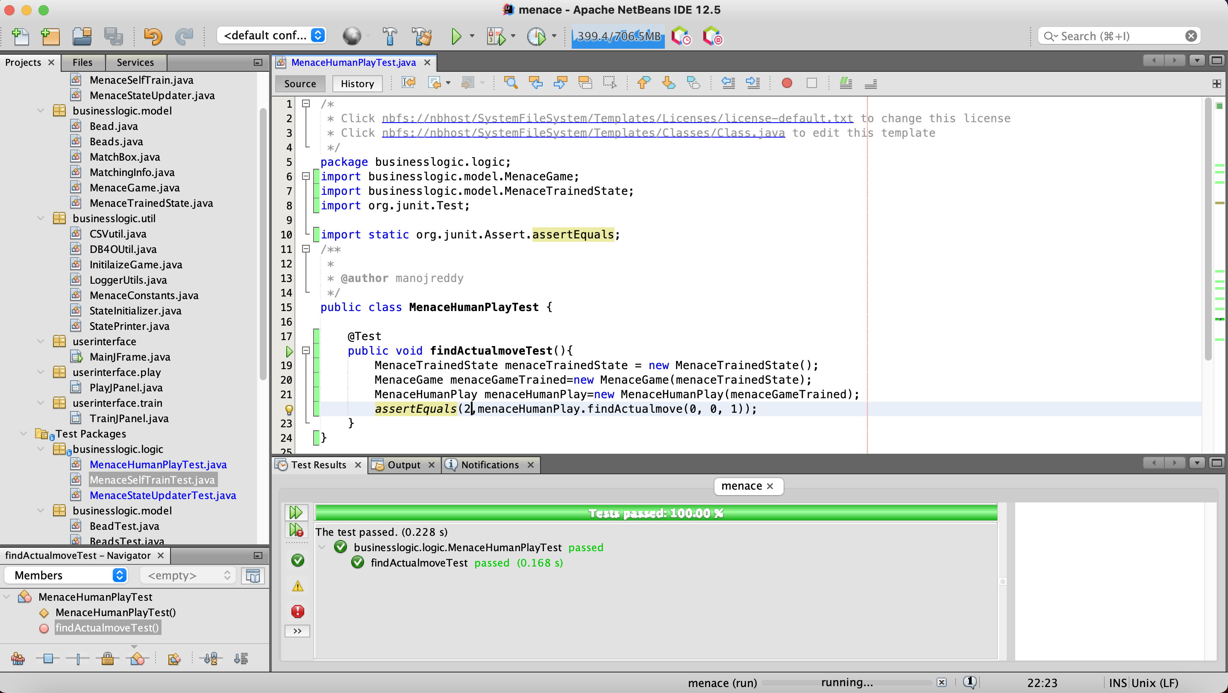

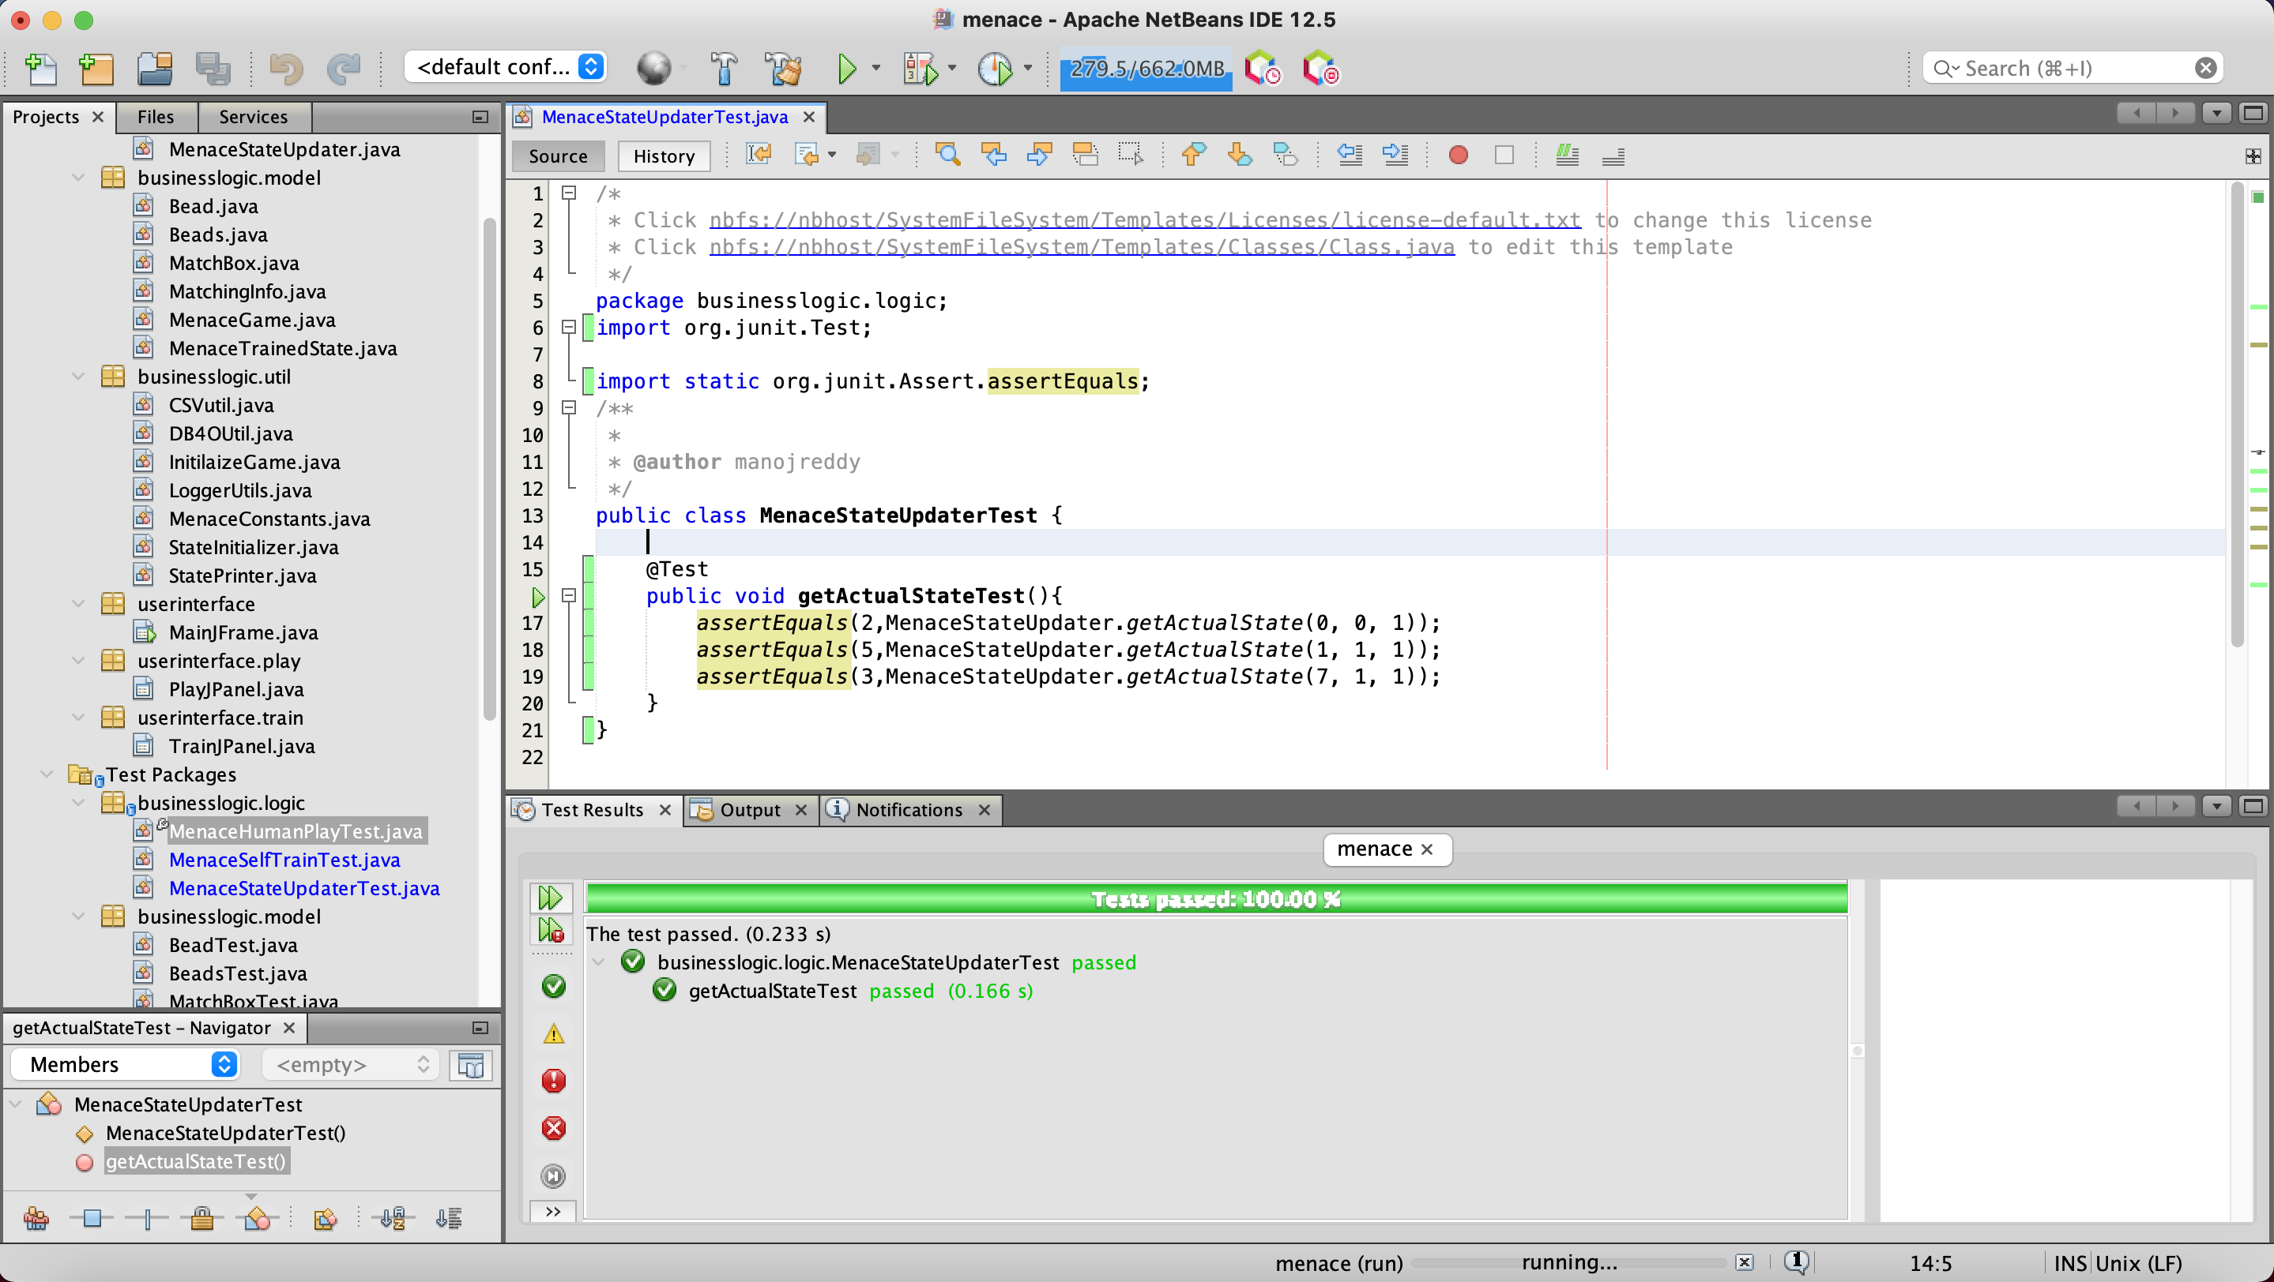

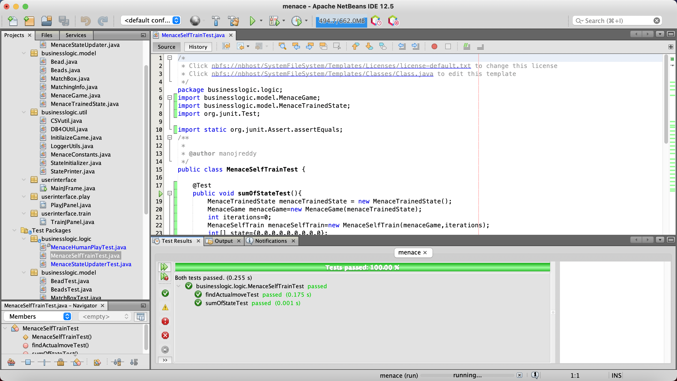

**Test cases for model classes:**

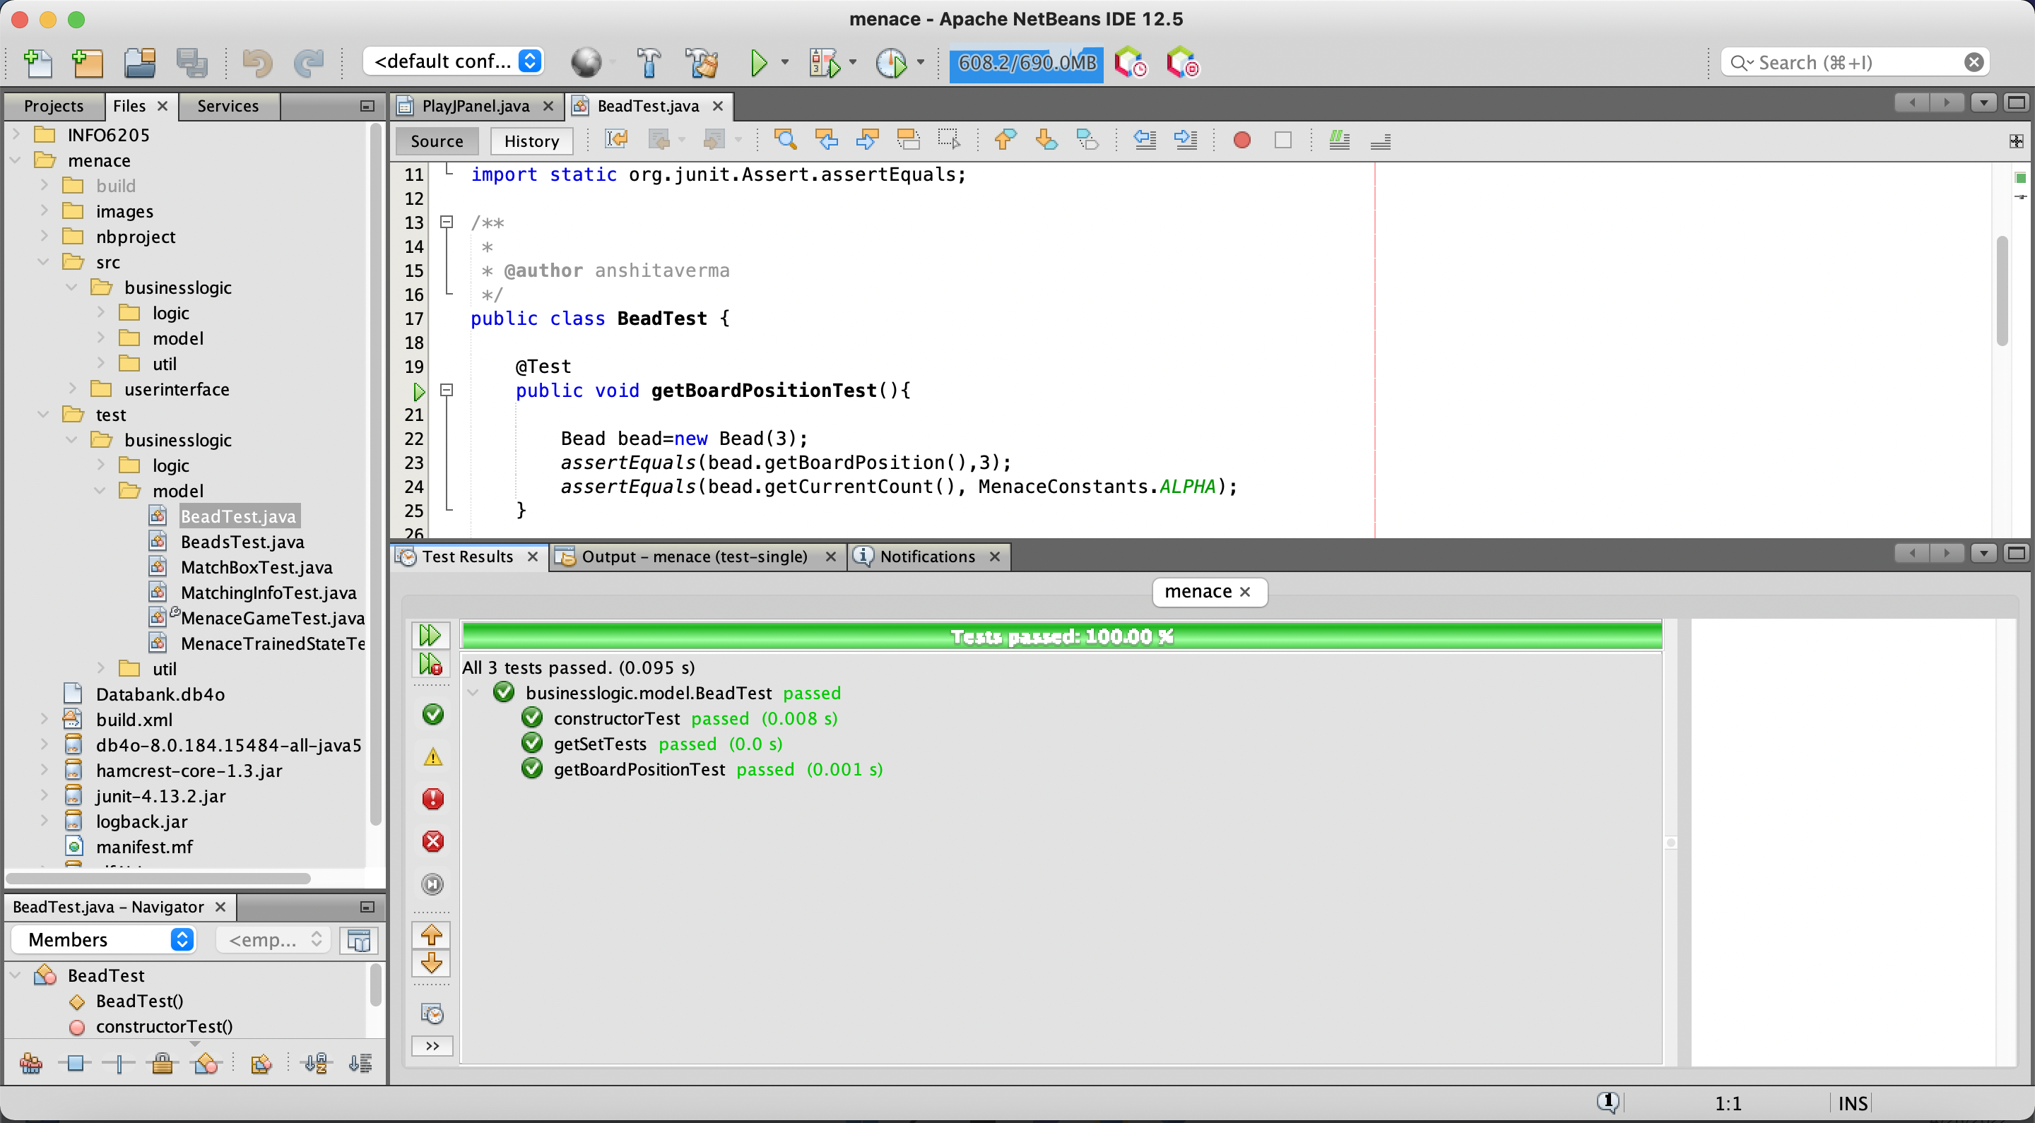

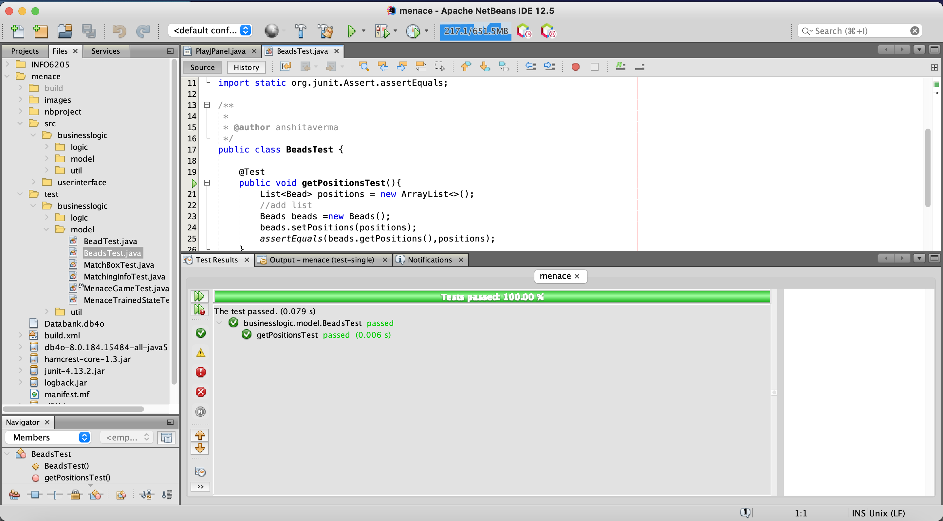

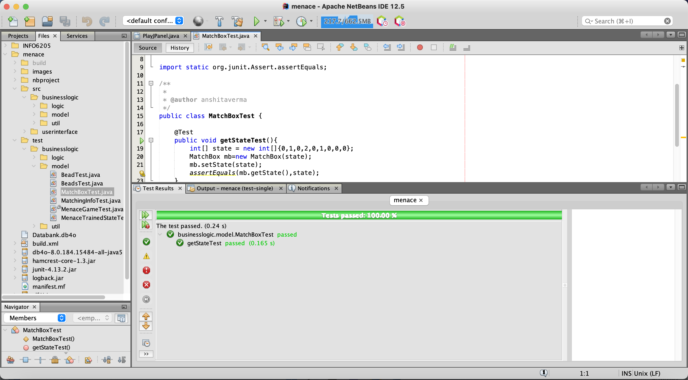

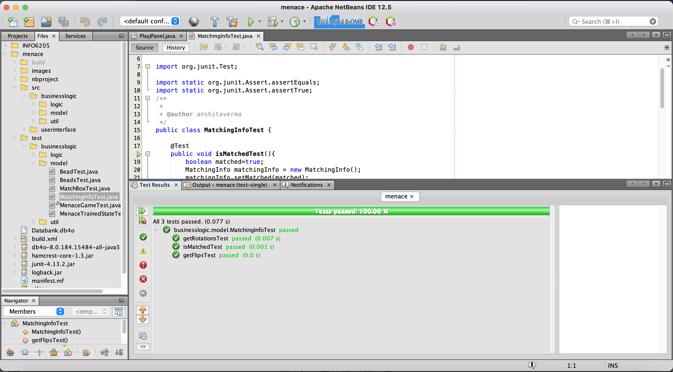

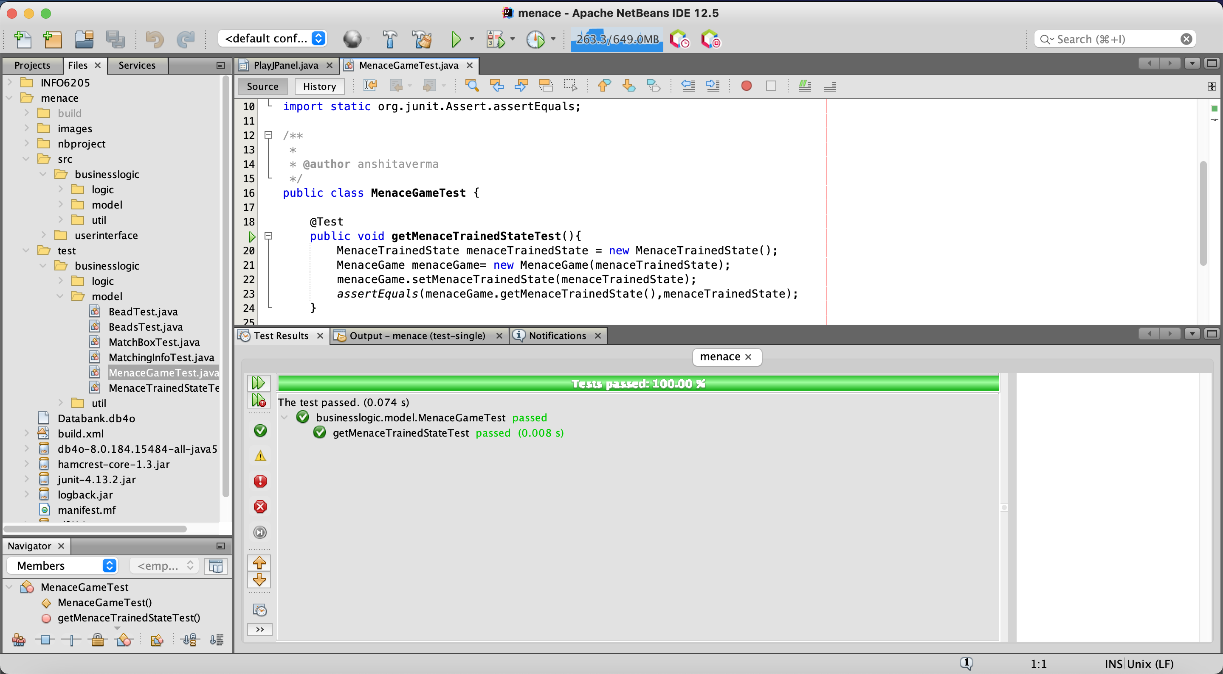

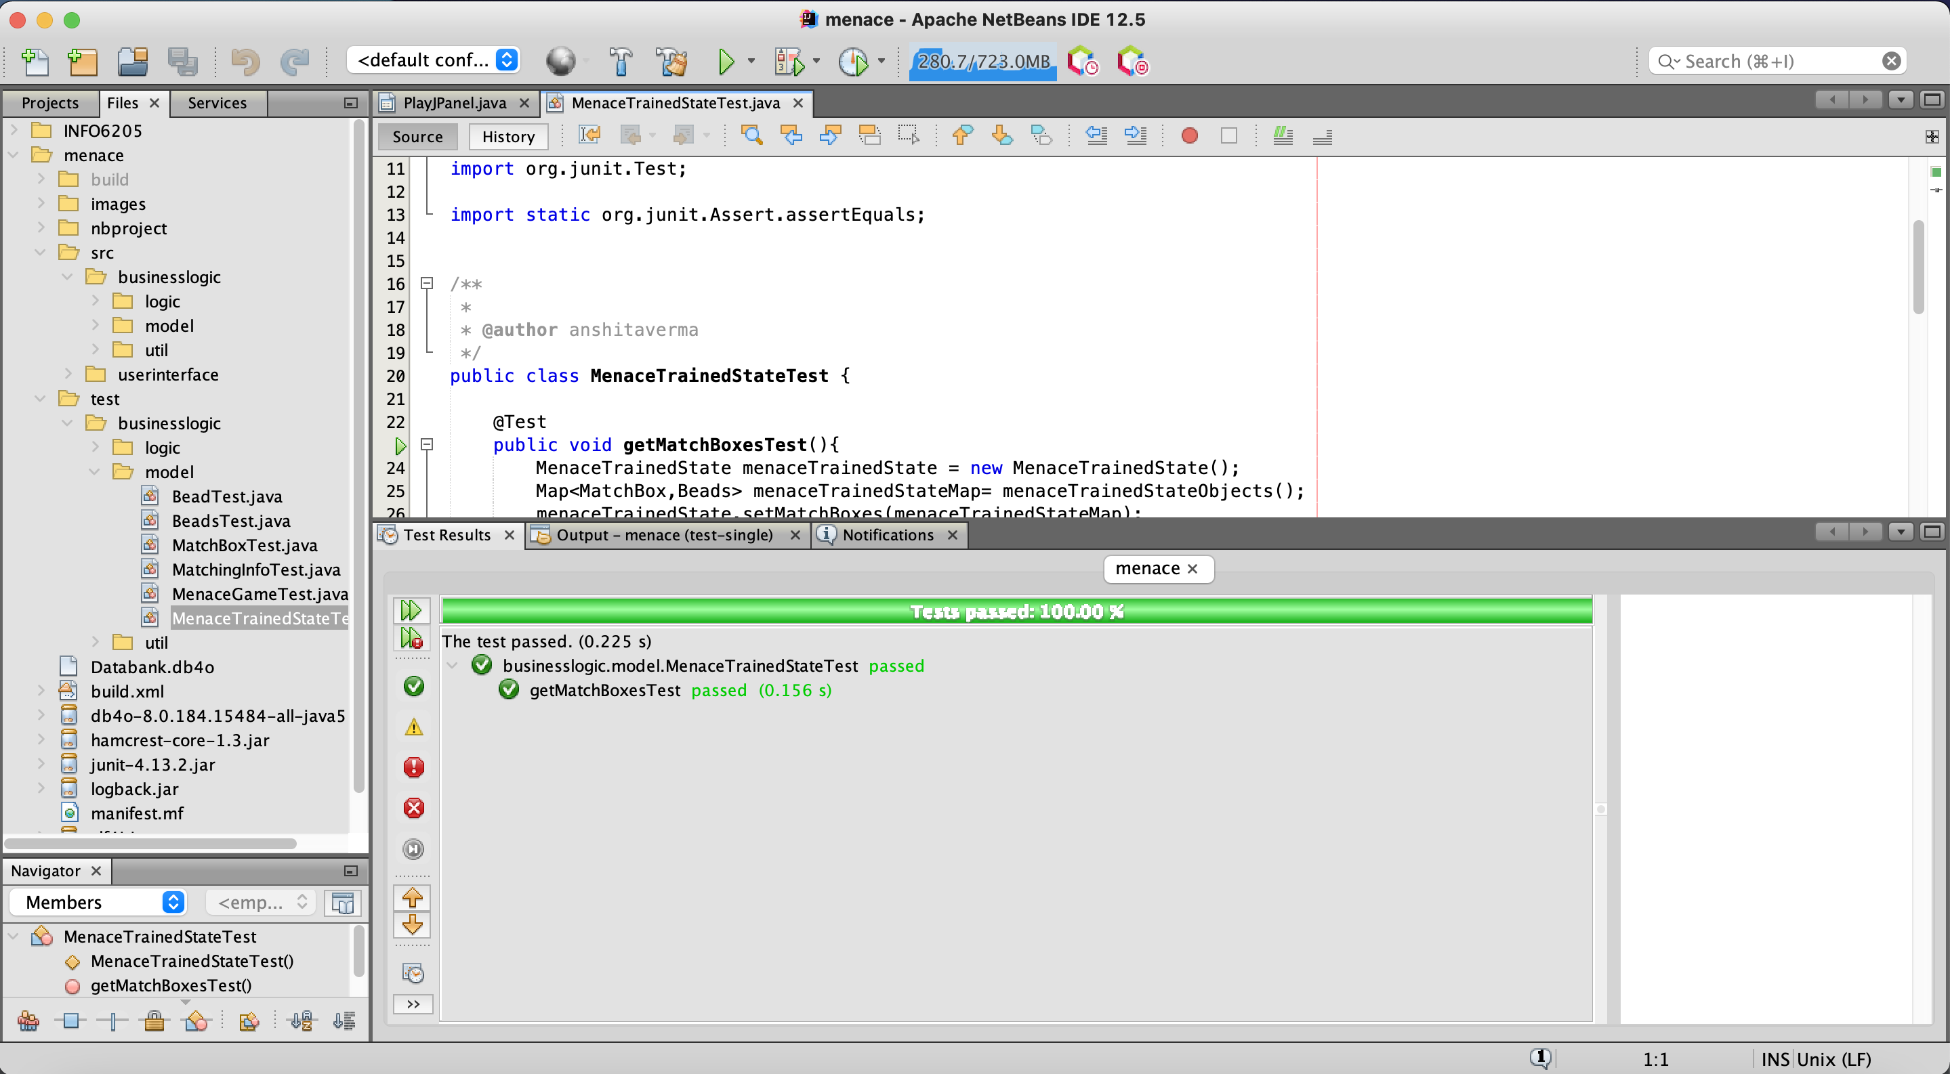

**Test cases for util classes:**

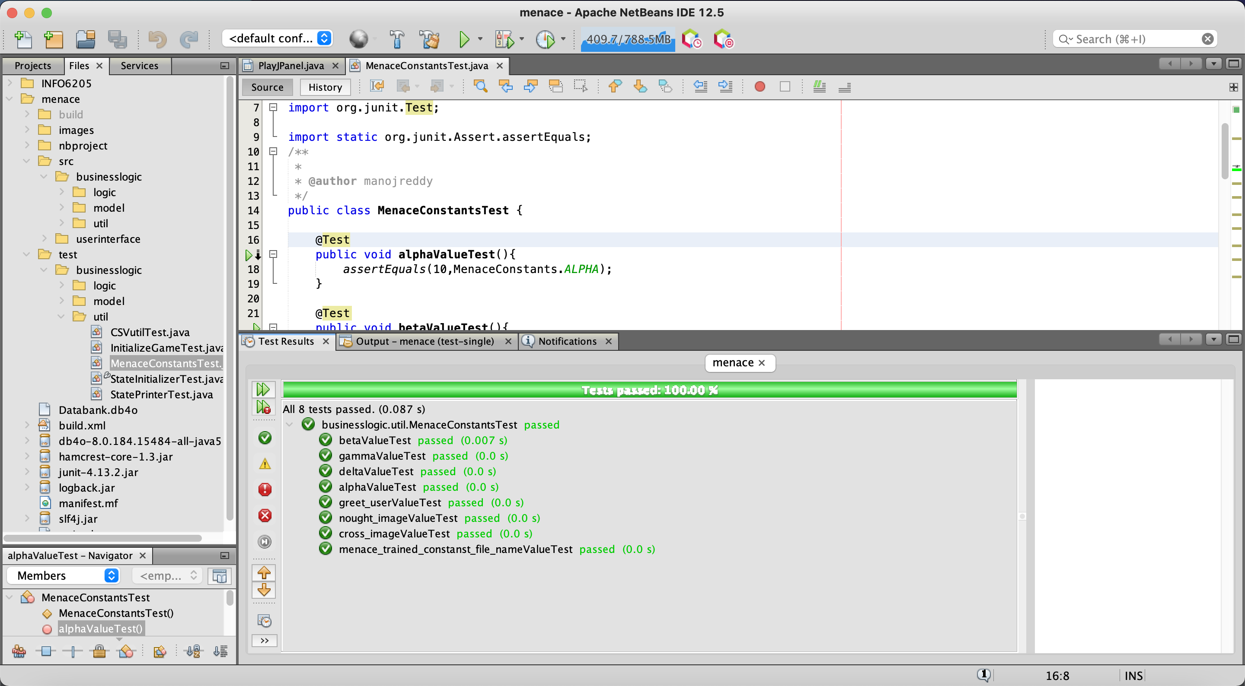

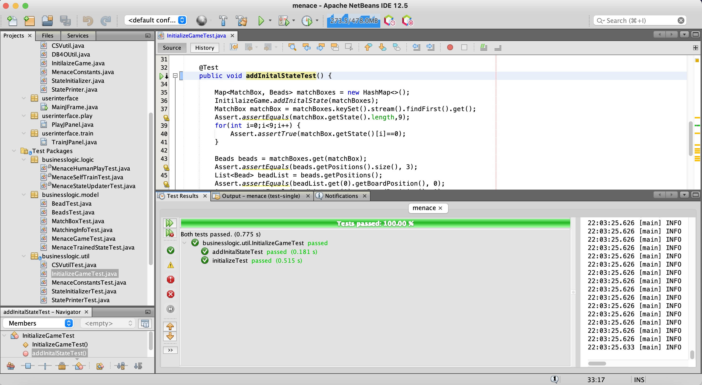

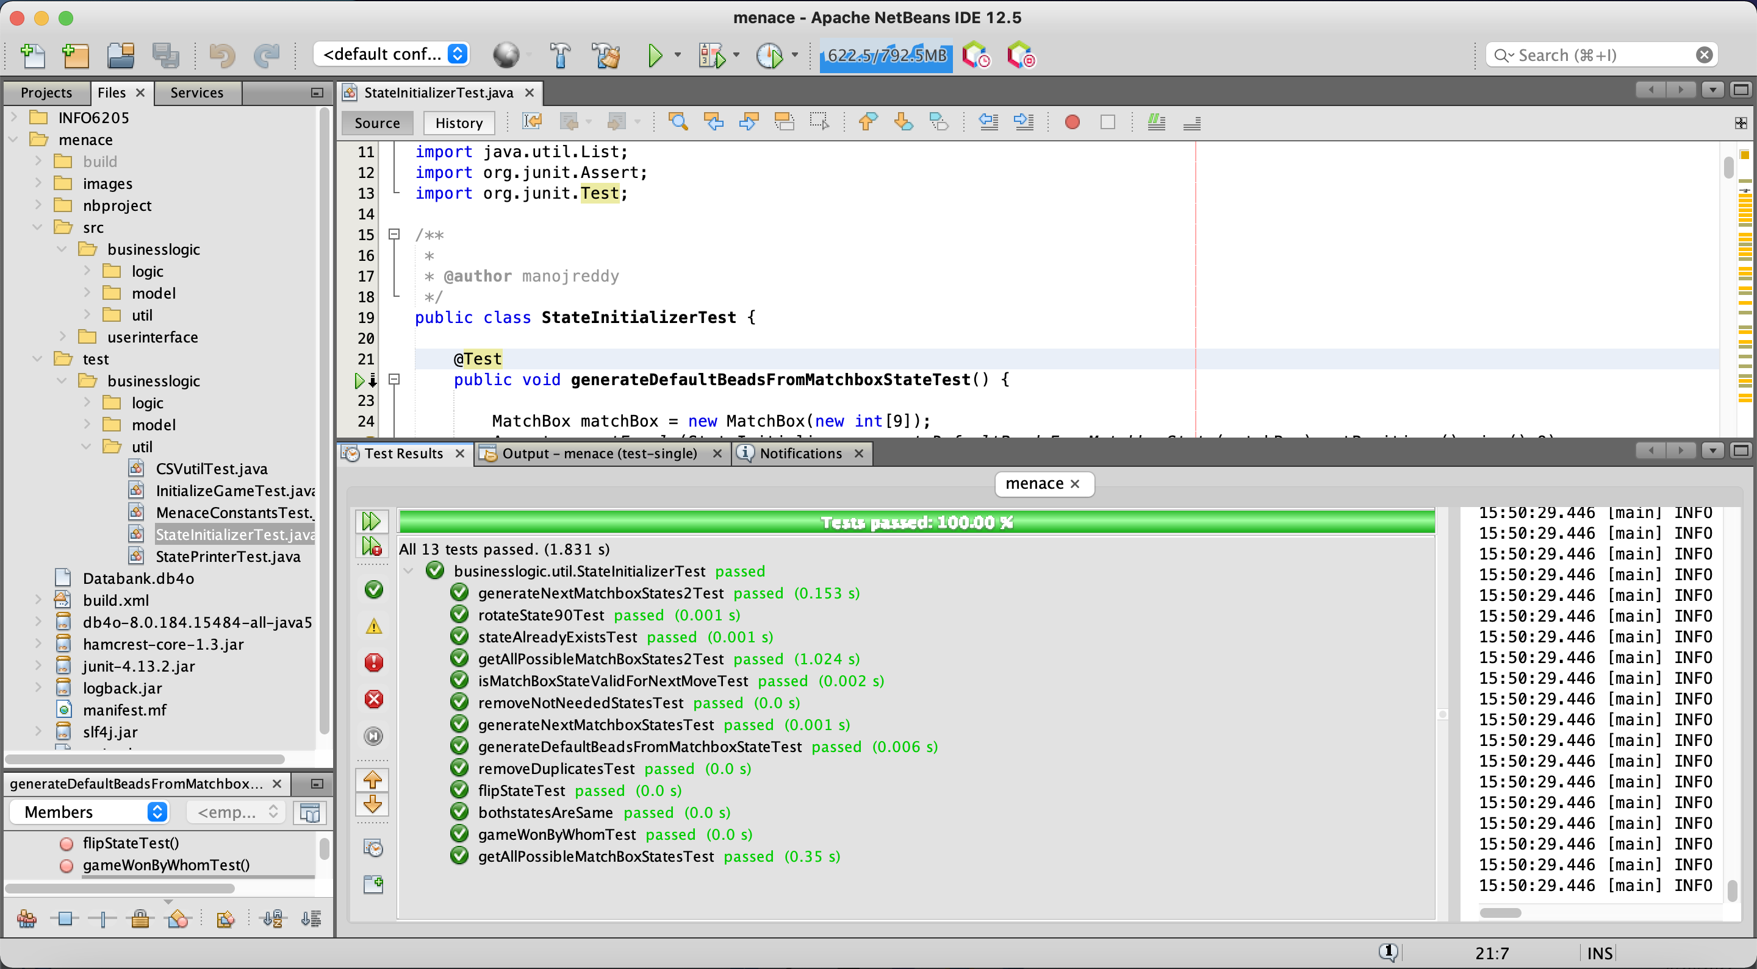

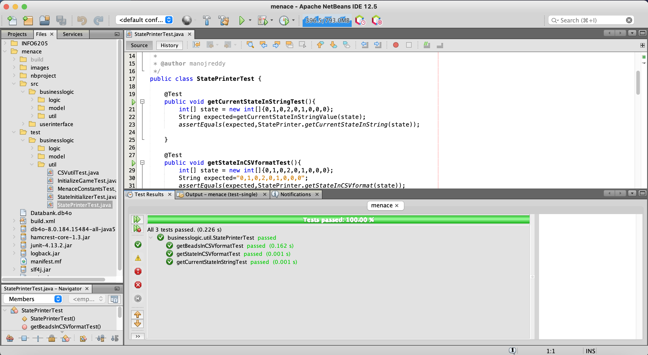

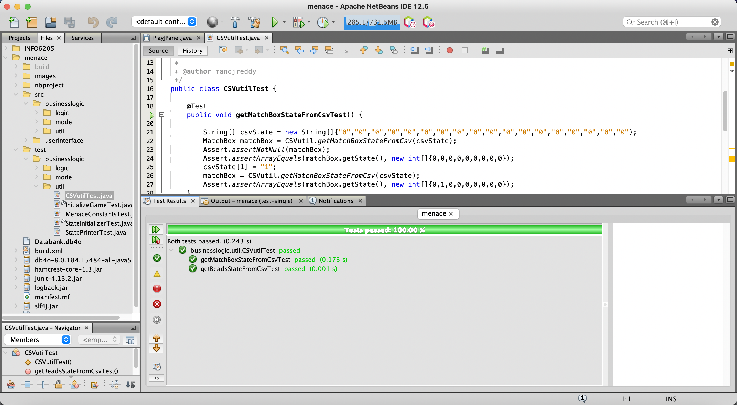

Conclusion

Since we are training the system with a Random Mover it trains the menace at all possible moves and helps in learning it better for the long term. So, we can expect the Menace to train better as we increase the number of games. But in order to train the system better we can further enhance the algorithm by dynamically changing the Beta, Gamma and Delta values based on a cost function. Also, by making some intelligent moves by human data set.

References

* <https://en.wikipedia.org/wiki/Tic-tac-toe>
* <https://www.youtube.com/watch?v=TtisQ9yZ2zo&t=2210s&ab_channel=TheRoyalInstitution>
* <https://www.mscroggs.co.uk/blog/19>
* <https://people.csail.mit.edu/brooks/idocs/matchbox.pdf>